NordaTrade GmbH
Enterprise Sales Analytics System
Schema Design Document

Entity-Relationship Diagram (ERD)

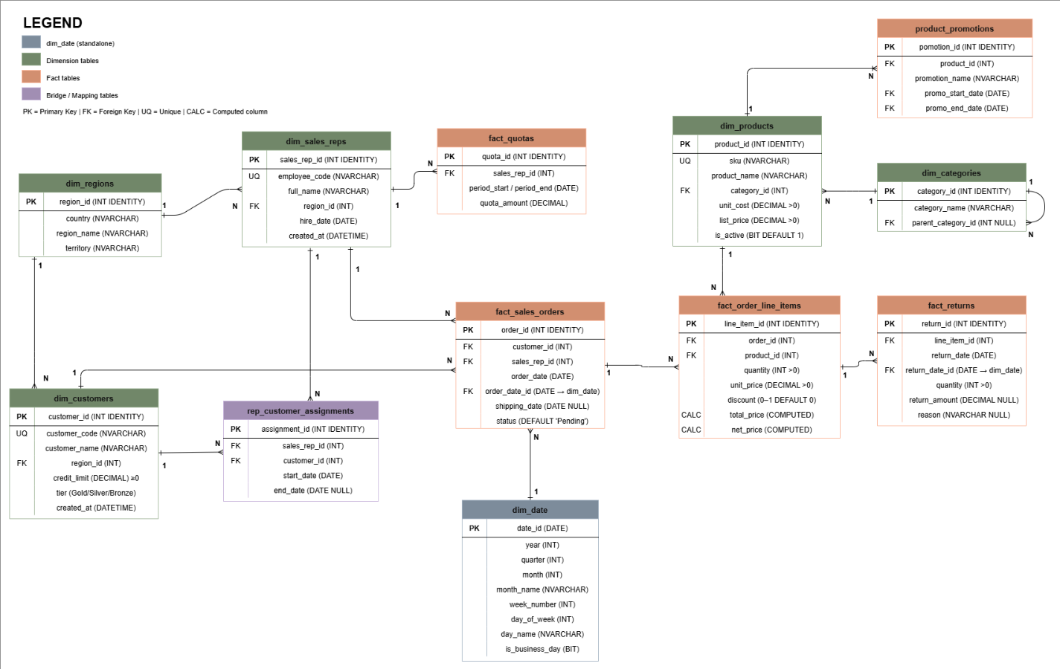

The Entity-Relationship Diagram (ERD) presents the complete logical structure of the NordaTrade database and shows how all entities are connected in a realistic sales analytics environment. The model includes dimension tables, fact tables, and bridge/mapping tables, each with a clearly defined role in the overall architecture.

Dimension tables (dim_customers, dim_sales_reps, dim_products, dim_categories, dim_regions, and dim_date) store descriptive business context, while fact tables (fact_sales_orders, fact_order_line_items, fact_returns, and fact_quotas) store measurable transactional activity. This separation improves clarity, supports scalable reporting, and reflects best practice in analytical database design.

The ERD also defines cardinality for each relationship. For example, one customer can place many orders, one order can contain many line items, and one product can appear in many order line items. Product categorization is modeled through a hierarchical structure in dim_categories table, where each category may reference a parent category. This enables both high-level and drill-down reporting.

A key relationship in the model is the many-to-many business association between sales representatives and customers, implemented through the rep_customer_assignments bridge table. This design captures assignment history using start and end dates, ensuring that changes over time can be analyzed accurately.

Overall, the ERD demonstrates a robust and business-oriented schema. It enforces data integrity through primary and foreign keys, captures real operational workflows, and provides a reliable foundation for KPI reporting, trend analysis, and decision support.

Schema Design Document
The NordaTrade database schema was designed to simulate a realistic sales business environment while remaining clean, logical, and easy to analyze. The structure emphasizes clarity, data quality, and long-term usability. Instead of storing information randomly, each table has a specific role and contributes to a complete analytical workflow. This approach allows users to move smoothly from raw transactional records to meaningful business insights.

Dimension tables describe business entities such as customers, products, sales representatives, regions, and dates. Fact tables capture measurable events such as orders, line items, returns, and sales quotas. Bridge tables model changing relationships, such as customer assignments to sales representatives and active product promotions. By separating descriptive context from transactional activity, the model becomes easier to query, maintain, and expand.

A key component is the dim_customers table, which stores customer identity and profile attributes. It includes customer code, name, region, credit limit, and customer tier. The use of unique constraints prevents duplicate customer records, while check constraints ensure values remain valid. For example, credit limits cannot be negative, which protects financial analysis from incorrect entries.

The dim_sales_reps table stores employee details and links each representative to a region. This enables performance analysis by territory and supports fair comparison between representatives working in different markets.

The dim_products table stores product-level details such as SKU, product name, category, unit cost, and list price. Since products are central to profitability analysis, enforcing positive values for cost and price is critical. The is_active flag is especially useful, because it allows historical products to remain in the system even when they are no longer sold. This preserves reporting continuity and avoids data loss in trend analysis.

Supporting this, the dim_categories table introduces hierarchical classification through parent-child relationships. This allows analysts to aggregate data by high-level groups while still drilling down into specific subcategories.

The dim_regions table captures country, region, and territory. Geographic modeling is essential in sales analysis because market behavior often varies by location.

The dim_date table acts as a time-intelligence layer, storing year, quarter, month, week, day name, and business-day indicators. This significantly improves reporting speed and consistency, because time logic is pre-modeled and reusable instead of recalculated in every query.

On the transactional side, the fact_sales_orders table records each order and links it to the customer and assigned sales representative. It stores operational details such as order status, shipping date, and order total, making it a core source for operational and performance dashboards.

The fact_order_line_items table extends this by recording each sold item per order, including quantity, unit price, and discount. It also contains computed columns such as total_price, discount_amount, and net_price, which standardize key calculations and reduce repetitive logic in reports.

The fact_returns table captures returned items and reasons for return, allowing deeper quality and satisfaction analysis. Return behavior can be monitored by product, category, region, or representative to identify potential process or product issues.

The fact_quotas table stores target amounts per representative and time period, enabling structured performance management. Comparing quota values against achieved sales provides a clear view of productivity and goal attainment.
Bridge and support tables further improve real-world accuracy.

The rep_customer_assignments table models assignment history using start and end dates, which is important when customer ownership changes over time. This ensures historical reports remain accurate for the correct representative-period combination.

The product_promotions table links products to campaign windows and discount rates, allowing the business to evaluate promotional effectiveness and understand how discounts influence order volume and margin.

Another strong aspect of this schema is its rigorous use of data integrity controls. Primary keys provide row-level identity, foreign keys enforce valid relationships across tables, unique constraints protect against duplication, and check constraints prevent invalid domain values. These controls transform the database from a simple storage system into a trusted analytical foundation.

From a practical perspective, this design supports a wide range of business use cases: top-customer ranking, regional sales trends, return-rate monitoring, product profitability analysis, sales rep performance scoring, and quota attainment tracking. Because the model is normalized where needed and analytically oriented where useful, it balances data governance with reporting performance.

In conclusion, the NordaTrade schema is more than a technical implementation; it is a business-ready data architecture. It enables reliable reporting, supports advanced SQL analysis, and provides a strong learning framework for beginners who want to understand how real organizations structure data for decision-making. As project complexity grows, this schema can be extended with indexes, additional dimensions, and BI-layer integration without requiring a complete redesign, making it a durable foundation for future development.

Full DDL Scripts
The Data Definition Language (DDL) scripts in this project are designed to be repeatable and execution-safe.
This means the schema can be recreated multiple times during development and testing without manual cleanup or dependency conflicts.
The script first verifies whether the NordaTrade database exists. If it does not exist, it is created.
Before recreating tables, existing objects are dropped in dependency-aware order (fact/bridge tables first, then dimension tables) to avoid foreign key violations. This approach ensures clean reruns and consistent schema state.

IF DB_ID('NordaTrade') IS NULL
CREATE DATABASE NordaTrade;
GO
IF OBJECT_ID('fact_returns') IS NOT NULL DROP TABLE fact_returns;
IF OBJECT_ID('fact_order_line_items') IS NOT NULL DROP TABLE fact_order_line_items;
IF OBJECT_ID('fact_sales_orders') IS NOT NULL DROP TABLE fact_sales_orders;
...
IF OBJECT_ID('dim_customers') IS NOT NULL DROP TABLE dim_customers;

Each table is then created with strong structural controls:
- Primary Keys (PK): uniquely identify each record.
- Foreign Keys (FK): enforce valid relationships between related tables.
- NOT NULL constraints: ensure mandatory fields are always populated.
- UNIQUE constraints: prevent duplicate business identifiers (e.g., customer code, employee code, SKU).
- CHECK constraints: validate acceptable value ranges (e.g., positive prices/quantities, valid tier values, discount limits).
- DEFAULT constraints: automatically assign standard values where appropriate (e.g., status defaults, timestamps, active flags).

The schema also includes computed columns (such as total and net values in line items) to standardize calculations and reduce repetitive logic in analytical queries.
Overall, the DDL implementation is structured not only to create tables, but to enforce data integrity, reduce input errors, and provide a stable foundation for reporting and KPI analysis.

Data Seeding Strategy
The data seeding strategy in this project is designed to create a realistic but controlled business dataset for analytical SQL practice. The objective is not only to populate tables, but to generate data with meaningful patterns so that KPIs, joins, and reporting queries produce believable results.

The process begins by making the script rerun-safe. Existing transactional and master data are cleared in dependency order, identity values are reseeded, and temporary staging tables are dropped if they already exist. This ensures that each execution starts from a clean state and produces consistent, testable results.
Data generation follows referential integrity rules by loading tables in a strict sequence. First, core dimensions are inserted: date, regions, categories, products, sales representatives, and customers.

Then transactional facts are loaded: sales orders, order line items, quotas, assignments, promotions, and returns. This order guarantees that foreign key references are valid at insert time. The dim_date table is seeded with a multi-year calendar range (2022-01-01 to 2026-12-31), including year, quarter, month, week number, day name, and business-day indicators. This allows immediate support for time-series analysis without recalculating date attributes inside every query.

Regional and category master data are inserted with fixed records, creating a stable reference framework across countries and territories, as well as parent-child product category hierarchy. This gives consistency to geographic and category-level reporting.
Customer seeding is intentionally distribution-based rather than fully random. The script generates at least 500 customers and assigns higher credit limits and premium tiers to selected segments, creating realistic variation between Gold, Silver, and Bronze customers. Regional assignment is also balanced to avoid extreme skew and to make territory-based analysis meaningful.
Product seeding generates at least 200 products. Product names include both generic and keyword-based labels, while cost and list price are generated with margin logic to simulate realistic profitability ranges.
The script also preserves active/inactive behavior through status flags, supporting both current and historical product analysis.
Sales representative seeding creates at least 50 records, each linked to a valid region. Quota records are generated by representative and quarter, with varying target values to simulate different performance expectations across teams and periods.

The transaction layer is the most behavior-rich part of seeding. The script currently inserts around 1,000 orders over multiple years, assigns customers and representatives, and varies order status (such as pending, shipped, delivered, and completed). Order line items are then created with quantity and discount variability, and computed columns automatically derive total and net values for cleaner downstream analytics.

Returns are seeded as a partial subset of sold line items, with generated reasons (e.g., damaged, wrong item, customer dissatisfaction). This supports return-rate KPIs, product quality analysis, and category-level return behavior studies.
Bridge and support tables are also seeded to reflect real operational conditions. Representative-customer assignments include time boundaries, allowing ownership changes over time. Product promotions include discount windows and date keys, enabling analysis of campaign effects on sales and margin.

Overall, this seeding strategy balances realism, integrity, and repeatability. It gives enough volume and variation for business analysis while remaining manageable for learning, debugging, and iterative query development.

Table Name | Purpose | Num. of Rows
dim_date | Calendar dimension (2022-01-01 to 2026-12-31) | 1,826
dim_regions | Geographic reference data | 20
dim_categories | Product category hierarchy | 19
dim_products | Product master data | 200
dim_sales_reps | Sales representative master data | 50
dim_customers | Customer master data | 500
fact_sales_orders | Sales order headers | 1,000
fact_order_line_items | Order item-level transactions | 1,200–1,400
fact_quotas | Quarterly targets by representative | 600
rep_customer_assignments | Rep-customer mapping history | 500
product_promotions | Promotional campaign records | 7
fact_returns | Returned line items | 180–260

Naming Convention Document
A consistent naming convention is applied across the NordaTrade schema to improve readability, maintainability, and team collaboration. Standardized naming reduces ambiguity, makes SQL scripts easier to debug, and helps new developers understand relationships quickly.

Table Naming Rules
All table names use lowercase letters with underscores (snake_case) and are prefixed by table role:

- dim_ for dimension tables (e.g., dim_customers, dim_products)
- fact_ for fact tables (e.g., fact_sales_orders, fact_returns)
- descriptive names for bridge/mapping tables (e.g., rep_customer_assignments, product_promotions)

This prefix-based structure immediately communicates the table’s analytical purpose.

Column Naming Rules
Column names are also written in lowercase with underscores and are descriptive by design.
Naming is kept semantic and business-oriented (e.g., credit_limit, order_date, return_amount) to make queries self-explanatory.

Key Naming Rules
Primary and foreign keys follow predictable patterns:

- Primary keys: <entity>_id (e.g., customer_id, order_id, product_id)
- Foreign keys: same name as referenced primary key to make joins intuitive
- Date keys: explicit naming (e.g., order_date_id, return_date_id, period_start_id)

This consistency makes relationship tracing straightforward in ERDs and SQL joins.

Constraint Naming Rules
Constraints use structured prefixes to indicate type and purpose:

- pk_ for primary keys
- fk_ for foreign keys
- uq_ for unique constraints
- ck_ for check constraints (when explicitly named)

Examples from the schema include patterns such as fk_order_customer, fk_line_product, and uq_region.
This approach simplifies troubleshooting because constraint intent is visible directly in error messages.

Optimization and Quality Review (Project Perspective)
In this project, our main goal was not only to build a working database, but to build one that makes sense for real business use. We started from the data model, created relationships, seeded the tables with realistic data, and then built business and analytical queries on top of that foundation. After completing those parts, we reviewed the project from an optimization point of view to make sure our work is practical, stable, and ready for larger workloads.

From the indexing side, we looked at how our own queries actually behave in the project. Since most of our reporting logic uses joins between orders, line items, customers, products, and dates, we focused index planning around those patterns. We did not treat indexing as a theory exercise; we connected each proposed index to real query usage from our phases. We also kept in mind that too many indexes can slow down inserts and updates, especially in fact tables. For that reason, our approach balances faster reads with acceptable write cost.

We also reviewed slow and complex queries that we created during the project. This helped us understand where performance issues can appear, such as large scans, expensive sorts, or heavy aggregations. Instead of only identifying the problem, we documented practical improvements like filtering earlier, reducing row volume before joins, and restructuring anti-join logic where needed. This gave us better confidence that our SQL is not only correct, but also more efficient.

Another important part was data consistency. In real systems, many errors happen when multi-step operations are only partially completed. In our case, examples include creating an order without successfully creating all line items, or assignment mismatches between customers and sales reps during order creation. To handle this, we rely on two layers: database constraints for structural integrity and transaction-based logic for business integrity. This combination keeps the dataset cleaner and prevents hard-to-debug inconsistencies later in reporting.

For the analytics layer, we reviewed our report views and discussed where materialization can help. Some views are queried often and involve heavier calculations, so precomputing those results can improve dashboard responsiveness. Other views can remain dynamic when freshness is more important than speed. This project-based view helped us define a practical refresh strategy instead of applying the same rule everywhere.

Finally, we prepared a production readiness checklist to make sure the project is complete beyond just SQL scripts. The checklist covers schema validation, data loading reliability, performance checks, transaction safety, backups, monitoring, security, and release sign-off. This gives us a clear final quality gate and shows that the project is prepared with a real engineering mindset.
Overall, this optimization review supports the rest of our documentation (schema diagram, seed process, query phases, and team contributions). It shows that the project is not only finished functionally, but also reviewed for performance, consistency, and maintainability in a practical and realistic way.

